36U ENCLOSURE 19" CABINET 800X600 FLOOR STANDING DATA RACK - VALUCAB
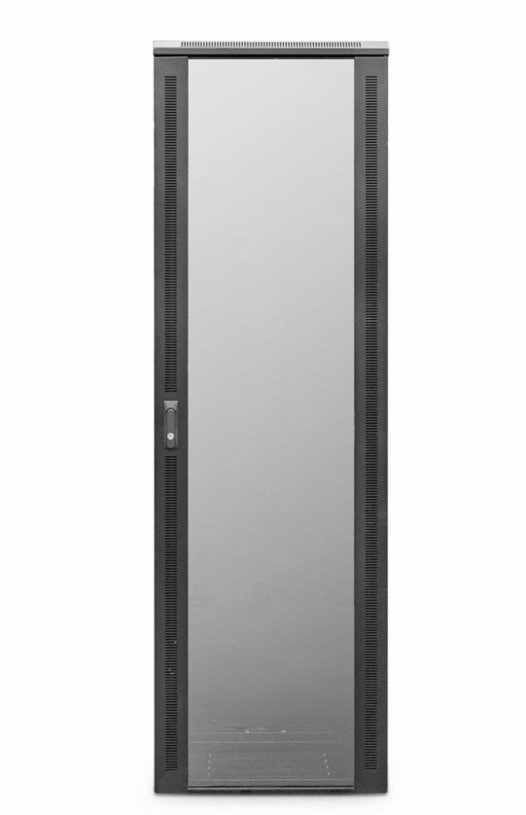

DESCRIPTION
The new LMS Data EcoNetCab range of Enterprise-level data cabinets, all of which are professionally assembled in the UK come with the quality and features you’ve come to expect from LMS Data. Available for a choice of professional installation scenarios, built from the ground up with quality alloys, robust powder coating and of course features to make pre and post installation easy, including adjustable front and rear ETSI 19-inch mount posts, gland plates, removable side panels and left/right hinged front safety glass door and solid rear door.

TECHNICAL SPECIFICATIONS
36U high 800W 600D
• 19"
• Colour: Black (Powder-coated RAL 9005)
• Dimensions: 800 (width) x600 (depth) x1780mm (height - inc. castors)
• Front tempered glass door (lockable)
• Left/right hinged front/rear doors
• Removable side panels for easy access
• U-numbered uprights for rack-mount product alignment
• Multiple cable entry glands for exact power and cabling entry

SUPPLIED WITH
Front Cable Management; Standard/Shipping Castors (Fitted): Set of 4 adjustable Jacking Feet (Supplied): Standard M6 Cage Nuts and Bolts (Supplied): Hex Adjusting Key (Supplied)

PRODUCT INFO
SKU/MPN: CAB-FE-36U-86NA
EAN: 8400800034694
Dimensions: 800 (width) x600 (depth) x1780mm (height - inc. castors)

FILES
﻿Specification Sheet (PDF)

